# Level-up CSP Technical Training – Power Platform

# Facilitator Guide

**Use case – Digitize and automate approvals using Power Platform**

|  |  |
| --- | --- |
| Description | A hands-on experience to inspire users to use Microsoft Power Platform tools to design and implement digital systems to meet business objectives. |
| Prerequisites | To get the most out of this lab guide we recommend you have Work-School, Admin Tenant ID and Password, Trial access with Power Apps for Developer, Lab Files (HomeScreen.png) |
| Audience | Microsoft partners will deliver this workshop to CSP customers, who have multiple employees in their company, have a Microsoft Power Apps for Developer and Microsoft Power Automate license, and have minimal Microsoft Power Platform experience. |
| Duration | 30 minutes |
| Publication date | November 2024 |

This document is provided “as-is”. Information and views expressed in this document, including URL and other Internet Web site references, may change without notice. You bear the risk of using it.

This document does not provide you with any legal rights to any intellectual property in any Microsoft product. You may copy and use this document for your internal reference purposes.

© 2024 Microsoft. All rights reserved.

Contents

Objective and scenario 4

Objective 4

Solution focus area 4

Personas and scenario 4

Pre-requisites 5

Lab instructions 6

Exercise 1: Create an Expense Report App 6

Task 1: Sign in to Power Apps 6

Task 2: Create a table with Microsoft Dataverse 6

Task 3: Build your application with Microsoft Dataverse 16

Task 4: Add a Home Screen 27

Task 5: Modify the Browse Screen 37

Exercise 2: Create an Expense Approval Request flow 41

Exercise 3: Test the app 55

Task 1: Submit an Expense Approval request 55

Task 2: Approve the Expense approval request 62

Task 3: View different stages of Expense approval request flow 64

Task 4: Reject the Expense approval request 69

# Objective and scenario

## Objective

Develop an Expense Report application that streamlines and automates the approval workflow for employee expenses.

## Solution focus area

Contoso Corp, a specialty Coffee Maker production company, manufactures both consumer and commercial Coffee Makers. Currently, Contoso Corp has been using a Microsoft Excel workbook to track employee expenses. When an employee embarks on a business trip, they enter their total travel expenses into a spreadsheet and then email the completed spreadsheet to the Manager of the Accounts department. After the Manager has approved the expenses, they will send the spreadsheet by email to the Accounts Officer, which has its own internal approval process. Finally, the employee will receive reimbursement.

Contoso Corp has faced several challenges with the current process, which is not only lengthy but also complicates version control when changes are required.

Contoso Corp needs a new solution that can:

* Create a mobile app so that employees can record expenses as they occur.
* Directly alert Accounts Officer of approvals automatically.
* Notify the employees about approval or rejection of the reimbursements.

Based on these requirements, you've decided to create a canvas app using Power Apps and an approval flow using Power Automate. You will use Microsoft Dataverse to store your data. Dataverse already has access to your users and works with canvas apps seamlessly.

## Personas and scenario

* **Remy Morris** - Digital Solutions Architect
* **Mark Brown** – Project lead
* **David Flores** – App developer
* **Jane Miller** – App tester

These personas will participate in the following sequential scenarios:

* Remy Morris, Digital Solutions Architect at Contoso Corp, creates and plans digital architecture that aligns with the business need and articulates this framework to Mark Brown, the Project Lead at Contoso Corp, and assists him in selecting the most suitable Power Platform tools for the implementation of the digital solutions.
* Mark Brown provides David Flores with an overview of the tools and processes involved in developing a canvas app using Power Apps and creating an approval flow using Power Automate.
* David successfully creates a canvas app and an approval flow, fulfilling all the requirements of Contoso Corp to streamline and automate the approval workflow for employee expenses, which he then submits to Jane Miller for testing.
* After thorough testing and validation, Mark Brown officially hands over the app to the team, enabling them to process the employee expense approvals efficiently.

# Pre-requisites

For this use case, all participants will need the following:

* Work – School or Admin Tenant Email Id and Password
* [Microsoft Power Apps for Developer license](https://www.microsoft.com/en-in/power-platform/products/power-apps/free) (Includes Power Automate License)
* [Microsoft 365 Business Premium/E3/E5 license](https://www.microsoft.com/en-in/microsoft-365/business)
* **HomeScreen.png** image file
* Their own devices with Wi-Fi connections.

**Note**

Please be aware that the user interface (UI) of Power Apps, Power Automate, and other related tools may change over time as Microsoft continues to update its products. However, the core concepts and logic behind their functionality will remain consistent. The principles you learn in this lab can still be applied, even if the UI looks different in the future.

# Lab instructions

## Exercise 1: Create an Expense Report App

In this exercise, you will create a data model in Microsoft Dataverse, build your application with the data model and add or modify screens in the app.

### Task 1: Verify your Dataverse environment

* 1. Open a browser and go to <https://admin.powerplatform.microsoft.com>. Sign in with your work /school/admin account.
  2. Select **Environments** on the left navigation. The **Developer environment** should have been created for you as shown in the image below. (This environment is created automatically as soon as you provide Microsoft Power app for Developer license using your work/school accounts. The name of the environment will be different for every admin account.)

* 1. Use the same developer environment to execute all the exercises of this lab.

### Task 1: Sign in to Power Apps

1. Use an In-Private or Incognito window and go to [Microsoft Power Apps](https://make.powerapps.com/).
2. Select the **Dev One** (Developer) environment from the **Environment** dropdown menu in the upper-right corner.

**Note**: For your tenant, the name of the environment can be different. Make sure that the environment that you have selected is a **Developer** environment)

### Task 2: Create a table with Microsoft Dataverse

Now that you have changed your default environment, it’s time to set up the application database.

1. On the left navigation, select **Tables**.

If the **Tables** tab is not visible on the left navigation, select **More** and then select **Tables**.

1. From the upper ribbon, select **New table > Set advanced properties**.

1. On the **New table** pane, on the **Properties** tab, enter the following information.
   * + **Display name** - Expenses on business trip
     + Select **Enable attachments**.

1. Select the **Primary column** tab, enter **Name of employee** in the **Default name** field and select **Save**.

1. You will be directed to a page informing you that your table has been provisioned successfully.

1. In the **Expenses on business trip columns and data** area, select **Create a new column** to add columns.

1. On the **New column** pane, enter the following information and select **Save**.
   * **Display name** – Email ID
   * **Data type** – Single line of format
   * **Format** – Text
   * **Required** – Business required

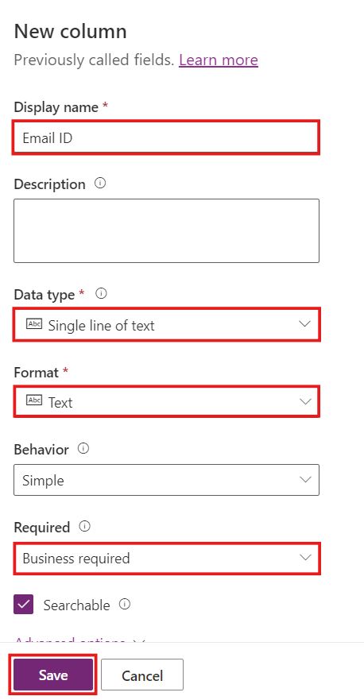

1. Once the column is saved, select the ‘**+**’ sign to add a new column.
2. Enter the following information in the **New column** pane and select **Save**.
   * **Display name** – Employee position
   * **Data type** – Single line of text
   * **Format** – Text
   * **Required** – Business required

1. Add a new column with the following details and then select **Save**.

* **Display name** – Trip destination
* **Data type** – Single line of text
* **Format** – Text
* **Required** – Business required

1. Add a new column with the following details and then select **Save**.

* **Display name** – Number of days of travel
* **Data type** – Number > Whole number
* **Required** – Business required

1. Add a new column with the following details and then select **Save**.

* **Display name** – Date of application
* **Data type** – Date and time > Date only
* **Format** – Date only
* **Required** – Business required

1. Add a new column with the following details and then select **Save**.

* **Display name** – Amount requested
* **Data type** – Number > Decimal
* **Required** – Business required

### Task 3: Build your application with Microsoft Dataverse

1. Select **Create** on the left navigation and then select **Dataverse**.

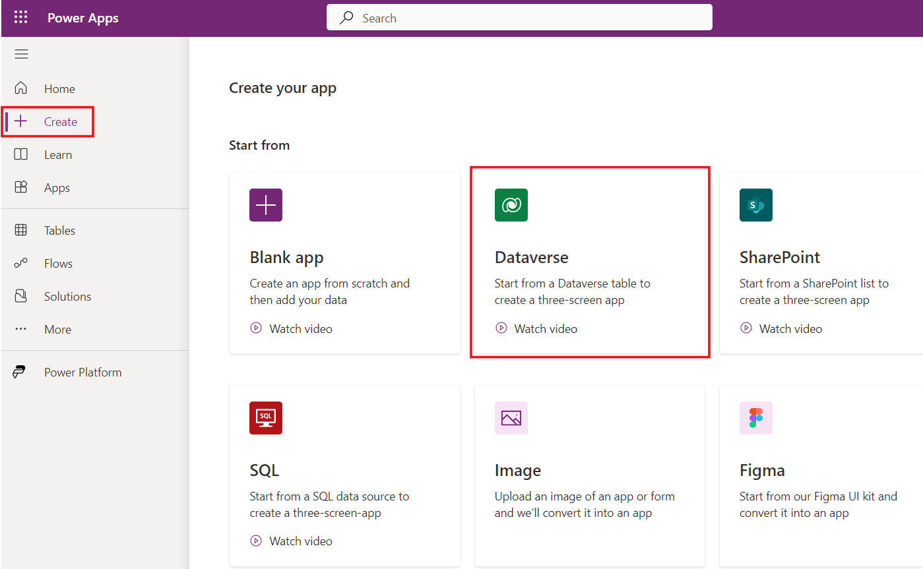

1. On the **Connections** page, select **New connection**.

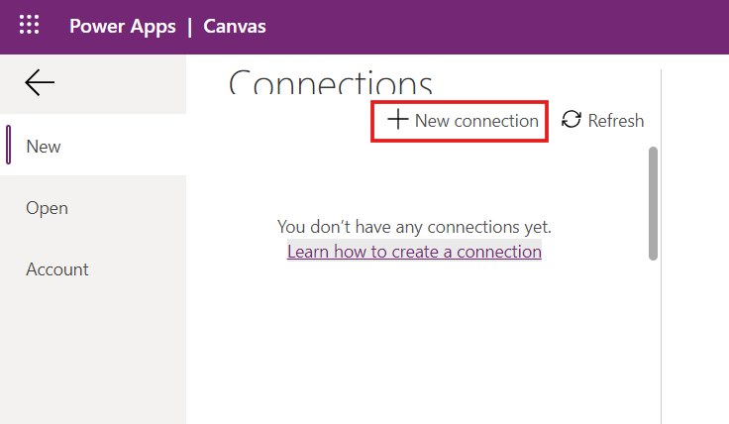

1. Select **Microsoft Dataverse** from the Connections list.

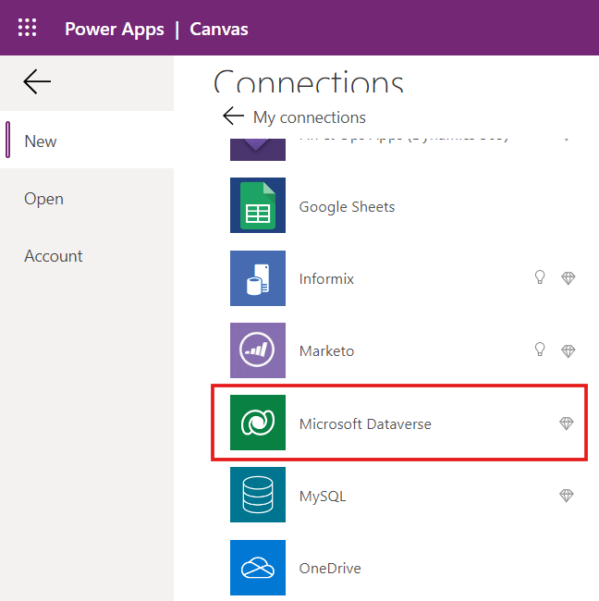

1. Select **Create**. A Sign-in pop-up will appear. **Sign in** with your **Tenant Admin credentials**.

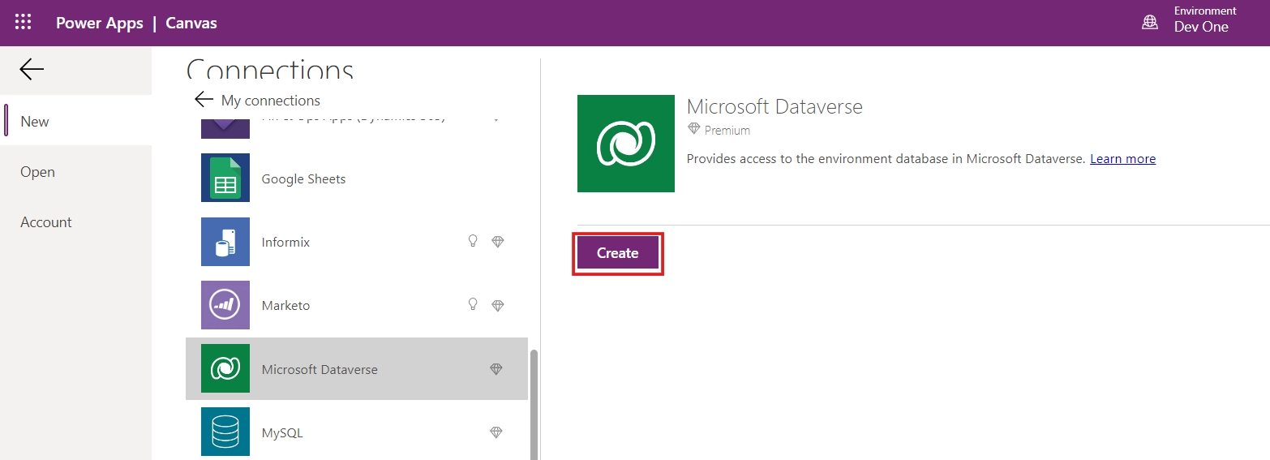

1. After signing in, select **Allow access** on the pop-up window.

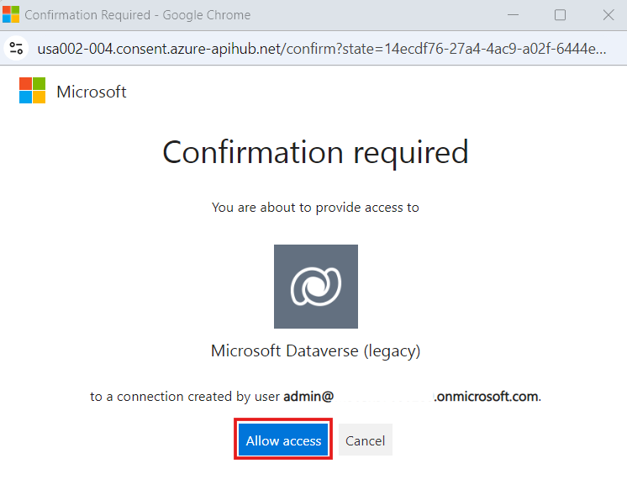

1. Once the Dataverse connection is established, you can see the tables in your environment. Choose **Expenses on business trips** table. Select **Connect**.

1. This will take you to the Power Apps Studio. Select **Skip** on the **Welcome to Power Apps Studio** dialog box.

1. Click on **App** on the **Tree view**. In the dialog that pops up on the right side of the screen, enter **Expense Report App** in the **App name** field.

1. Click on **DetailScreen** and from the drop down click on **DetailForm1**.

1. On the right-hand side of the screen, search for **Fields** and select the hyperlink in front of it.

1. Go to **Add field**, then select the fields that you created in your **Expenses on business trip** table. Thereafter, click **Add**.

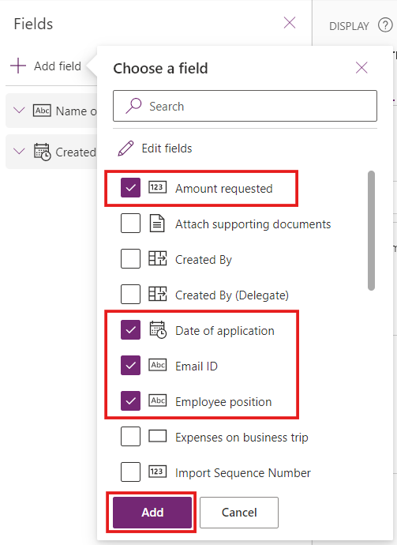

1. To remove the fields that are not required, select the ellipses by the side of the field and select **Remove**.

1. You can rearrange the fields in the preferred order you want them to show on your app. Click on the ellipsis sign (**…**) by the side of the field and move it to the position you want it to be.

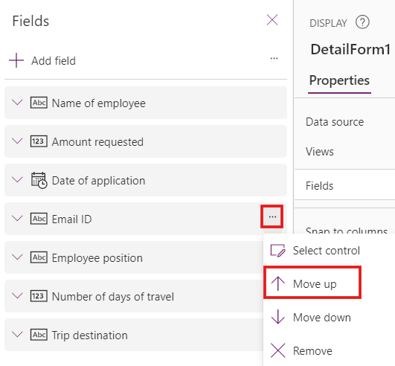

1. The fields should be arranged in the following order.
   * Name of employee
   * Email ID
   * Employee position
   * Trip destination
   * Number of days of travel
   * Date of application
   * Amount requested

1. Next, on the **Tree view** select **EditScreen** section and then select **EditForm1**.

1. On the right side of the screen under the section **Fields**, click the **Edit fields**.

1. Select **Add field**, then select the fields that you created in your **Expenses on business trip** table. Thereafter, click **Add**. Remove the fields that are not required.
2. Arrange the fields in the same format as in **DetailForm1**.

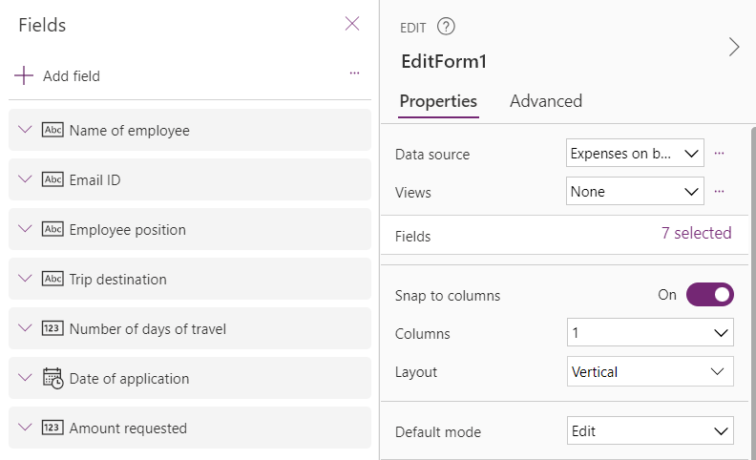

### Task 4: Add a Home Screen

1. Click on **New screen** at the top left corner of the screen and select **Blank**.

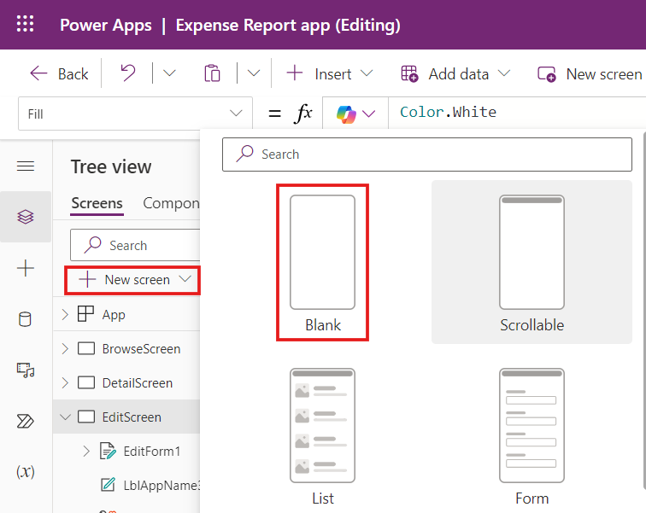

1. Add an image for visual impact on the **Home** screen. Select the **Media** button on the menu to the left of the tree view, and then select **Add media > Upload**.

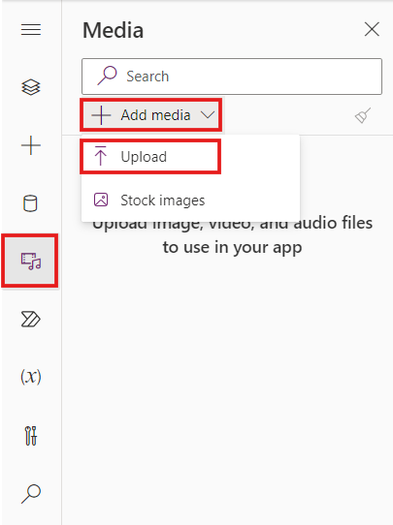

1. Select the **HomeScreen.png** file and upload it into your app.
2. Select the **HomeScreen.jpg** image from **Images** pane on the left side. The image will be seen on the **Home screen** of the app.

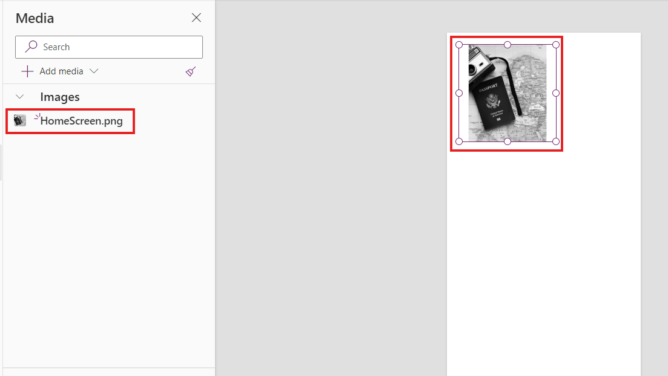

1. Now, you have the appropriate image on your **Home** screen.
2. Drag the corners of the **Image** control to resize the app and then position it to occupy about two thirds of the screen. You might notice an extra space above and below the picture because the image is a different size than the screen.

1. To correct this issue, change the **Image position** value from **Fit** to **Fill** on the **Properties** pane.

1. Change the following properties of your **HomeScreen** image.

* **X**: 0
* **Y**: 142
* **Width**: 640
* **Height**: 800

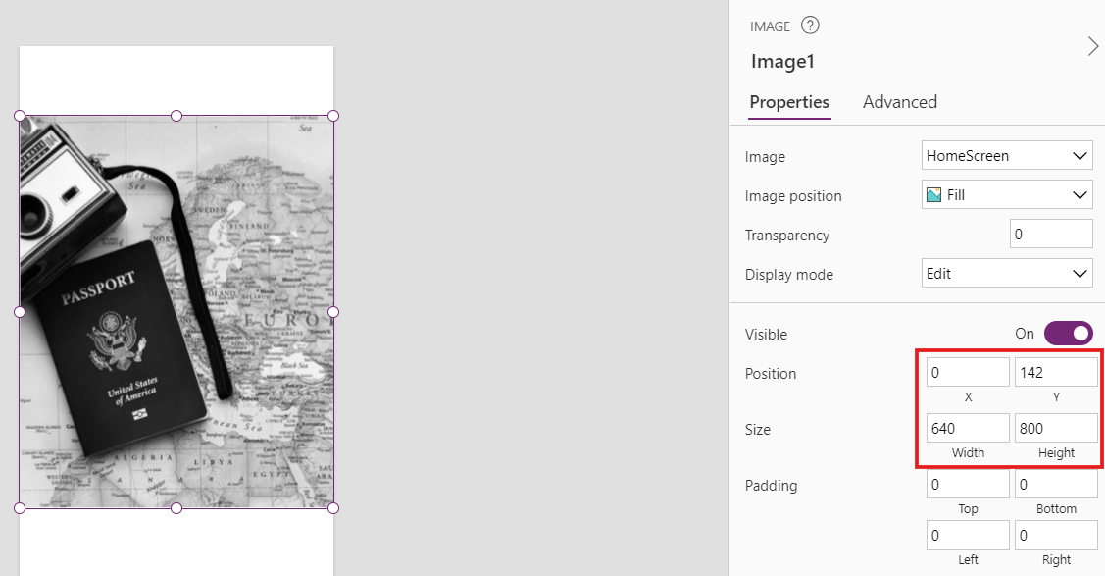

1. Click in the empty space above the image and then select **Insert**.
2. Select **Text label** to add a new label to your screen.

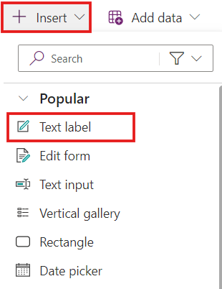

1. Change the following properties of your **Text label** control by using the **Properties** pane or the **Advanced** pane. Some properties are also available in the command bar.

* **Text**: Expense Report App
* **Size**: 30
* **Font Weight**: Bold
* **Text Alignment**: Center
* **X**: 0
* **Y**: 0
* **Width**: 640
* **Height**: 142

1. Now let's add a button to the **Home** screen that would take us to the next page whenever clicked. At the top of the screen select **Insert >** **Button**.

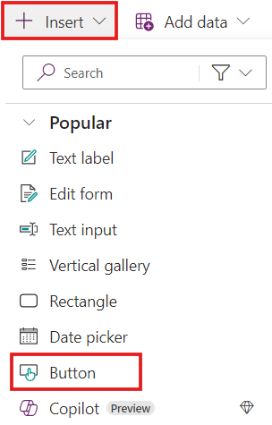

1. Change the following properties of your **Button** control by using the **Properties** pane or the **Advanced** pane. Some properties are also available in the command bar.

* **Text**: Register request
* **Size**: 24
* **Font Weight**: Semibold
* **Text Alignment**: Center
* **X**: 160
* **Y**: 999
* **Width**: 320
* **Height**: 70

1. Change the dropdown menu on the upper ribbon to **OnSelect**. This property sets the action of the button when a user selects it and is automatically set to false or do nothing.
2. Set the **OnSelect** property to ***Navigate(BrowseScreen)****.*

**BrowseScreen** is the name of the next screen.

1. Select the **Tree** view, select your **Home** screen. Select the ellipses by the side of the **Home** Screen and rename it to **Scr_Welcome**.

1. Select the **Scr_Welcome** screen and then select **Move up**. Move the **Scr_Welcome** screen to the top.

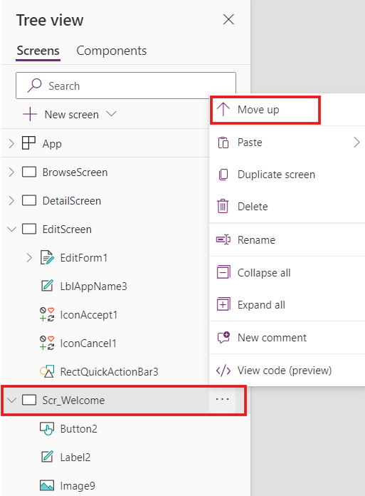

### Task 5: Modify the Browse Screen

1. Select the **BrowseScreen**. Select **Insert** and select **Button**.

1. Change the following properties of the **Button** by using the **Properties** pane or the **Advanced** pane. Some properties are also available in the command bar.

* **Text**: Back to Home
* **Font Size**: 24
* **Font Weight**: Semibold
* **Text Alignment**: Center
* **X**: 180
* **Y**: 1022
* **Width**: 280
* **Height**: 70

1. Change the **OnSelect** property for the button to ***Navigate(Scr_Welcome)****.*

1. Select the **Save** icon on the top-right corner to save your app.

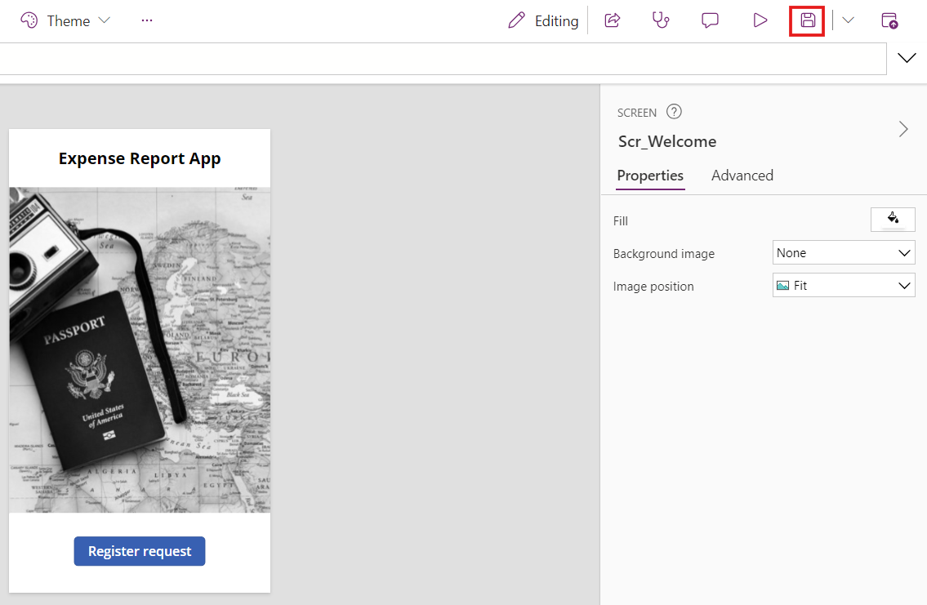

### Conclusion

Upon the conclusion of this exercise, you will possess:

1. **Expenses on business trip** table within Dataverse.
2. An **Expense Report App** developed using the **Expenses on business trip** table.
3. A **Home Screen** tailored for your application.
4. An enhanced **Browse Screen**.

This ensures that you will have a fully functional **Expense Report App**, inclusive of all necessary screens.

## Exercise 2: Create an Expense Approval Request flow

In this exercise, you will create an Expense Approval Request flow and integrate it with the Expense Report App.

1. On the **Tree view**, select **BrowseScreen** and then select **IconNewItem1**.

1. While keeping the **IconNewItem1** selected, click the **Power Automate flow** icon from the left bar.

1. Select **Create new flow**.

1. On **Create your flow** window, select **Create from blank**.

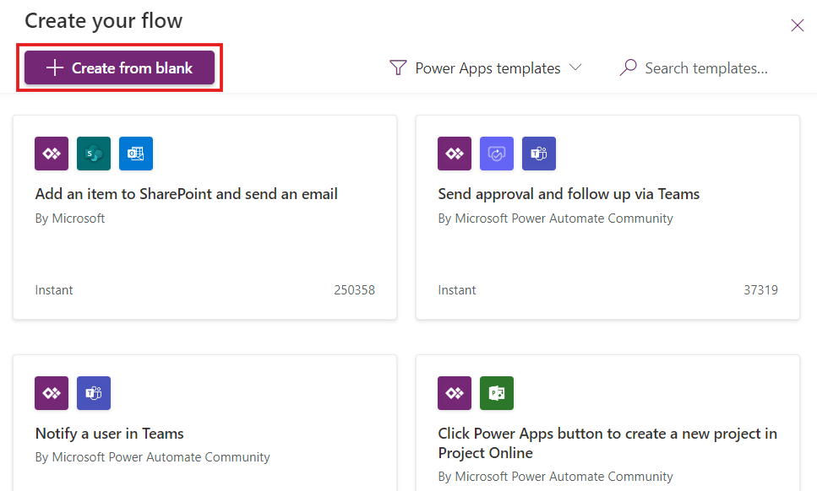

1. On **Create your flow** window, select the **New step** tab.

1. On **Choose an operation**, search for and select **When row is added, modified or deleted**.

1. Add the following information and then select **Next step**.
   * **Change type** – Added or modified
   * **Table name** – Expenses on business trip
   * **Scope** – Organization

1. On **Choose an operation**, search for and select **Start and wait for an approval**.

1. On **Send and wait for an approval** enter the following information.
   * **Approval type** – Approve/Reject – First to respond
   * **Title** – Approve the expense approval request
   * **Assigned to** – Enter your **Tenant Admin credentials**
   * **Details** – From **Dynamic content**, select **Name of employee**, **Employee position**, **Trip destination** and **Number of days of travel**

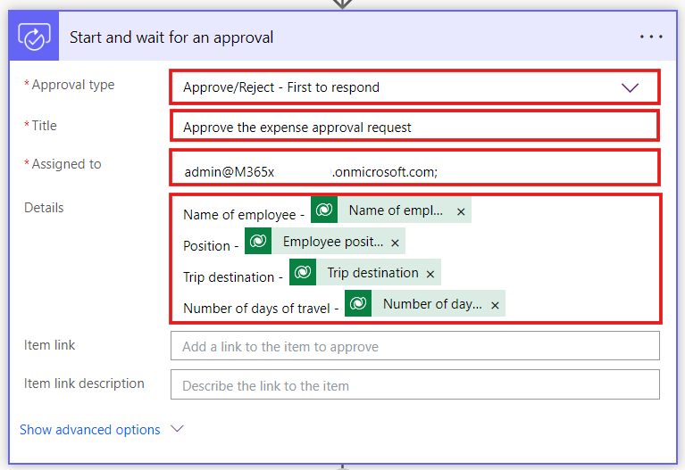

1. Add **New step**.
2. Select **Condition**.

1. Enter the following condition:

‘**Outcome is equal to Approve’**. Add **Outcome** from **Dynamic content**.

1. In the **If yes** branch, Select **Add an action**.

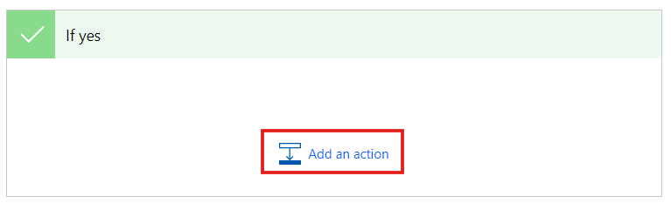

1. Search for and select **Send an email (V2)**.

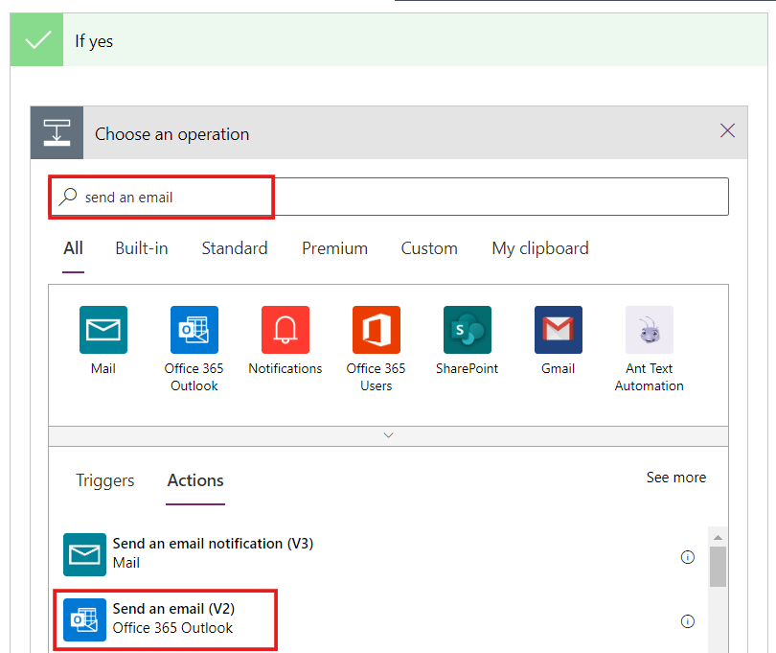

1. In the Send an email (V2) step, enter the following information.

* **To** – Add **Email-ID** from Dynamic content
* **Subject** - Expense request approved
* **Body** - Your expense request is approved.

1. In the **If no** branch, Select **Add an action**.

1. Search for and select **Send an email (V2)**.

1. In the Send an email (V2) step, enter the following information.

* **To** – Add **Email-ID** from Dynamic content
* **Subject** - Expense request rejected
* **Body** - Your expense request is rejected. Please check the comments by the Accounting Officer. Add **Responses Comments** from **Dynamic content**.
* As soon as you add **Responses Comments** from **Dynamic content**, the **Responses** field is added above **Send an email (V2)**.

1. Enter the name of your flow as **Expense approval request flow**.
2. Select **Save**.

1. Once the flow is saved, you will be navigated back to **Power Apps Studio**. The flow is added to the app.
2. **Save** your app.

1. Make sure that the **IconNewItem1** is selected.
2. Change the **OnSelect** property of **IconNewItem1** to *NewForm(EditForm1);Navigate(EditScreen, ScreenTransition.None);Expenseapprovalrequestflow.Run()*

1. **Save** the app.

### Conclusion

Upon the conclusion of this exercise, you will possess:

1. An **Expense approval request flow** created in Power Automate.
2. The **IconNewItem1** button integrated with the **Expense approval request flow**.

This integration guarantees that the **Expense Approval Request flow** functions smoothly with the **Expense Report App** and is triggered by the **IconNewItem1** button.

## Exercise 3: Test the app

In this exercise, you will test the app by submitting an expense approval request. When the flow runs, you will review the request as an Accounting Officer and then either approve or reject the request, check the respective notifications and finally verify different stages of the workflow.

### Task 1: Submit an Expense Approval request

1. Open a new tab on your browser and enter the URL <https://outlook.office365.com/> to browse **Microsoft Outlook**.
2. Sign in with your **Tenant Admin credentials**.

1. Navigate back to the **Power Apps** tab. To test your app, select **Tree view** and then select the **Scr_Welcome** screen.
2. Select the **Play** icon on the top-right corner.

1. Select **Register request** button on the **Home screen**.

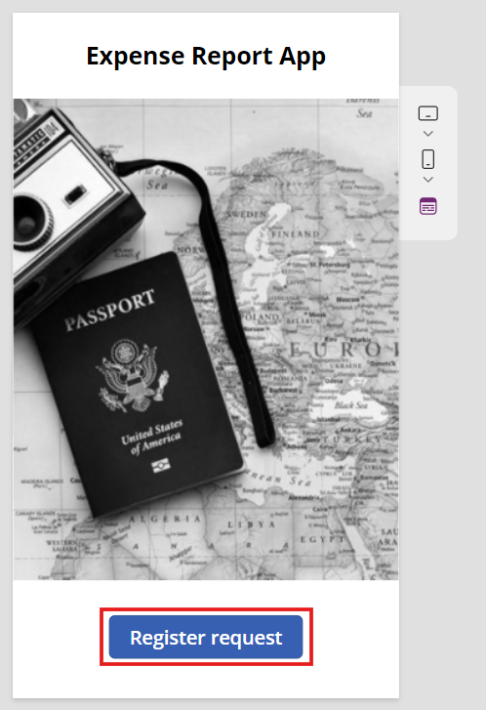

1. You will be navigated to **BrowseScreen**. Select the **+** sign.
2. On the **EditScreen**, enter the following information.
   * **Name of employee** – Mark Brown
   * **Email ID** – Enter your active Email ID
   * **Employee position** – Project Operations Manager
   * **Trip destination** - Seattle
   * **Number of days of travel** -3
   * **Date of application** – Select the date of application
   * **Amount requested** - 30000

1. Select the **Check mark** on the top-right corner.

1. Once the expense approval request is saved, you will be navigated to **BrowseScreen**. You can see the request enlisted on the **BrowseScreen**.
2. Select your recent request.

1. You will be navigated to the **DetailScreen** to check the details of your request.

1. You can **Edit** or **Delete** your request from the **DetailScreen**.

### Task 2: Approve the Expense approval request

1. Once you submit the **Expense approval request**, you will receive an email on your **Tenant Admin Outlook account**.
2. The email contains all the details of the requestor.
3. Check the details and select **Approve**.

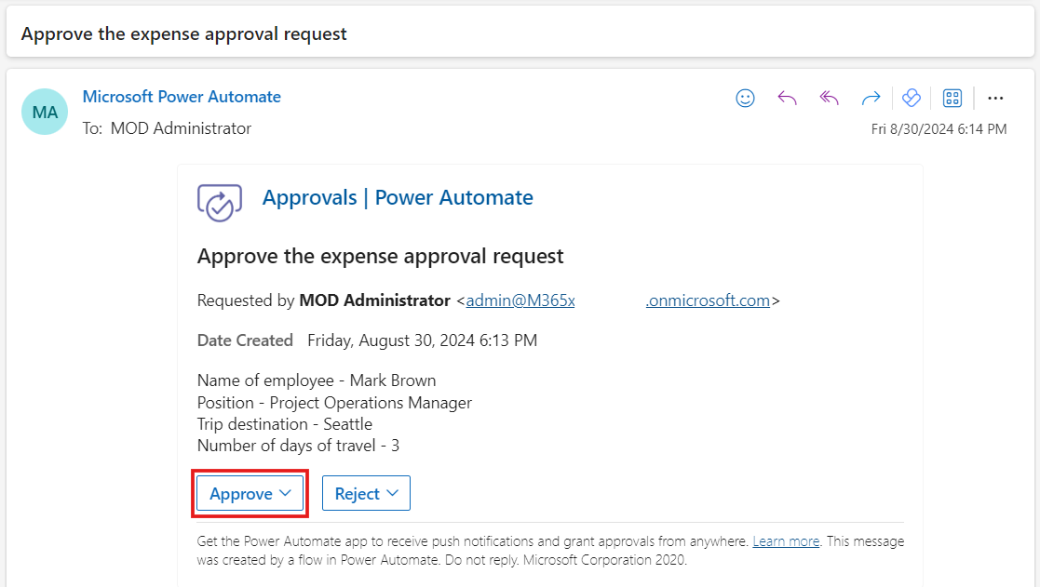

1. **Add comments** and then select **Submit**.

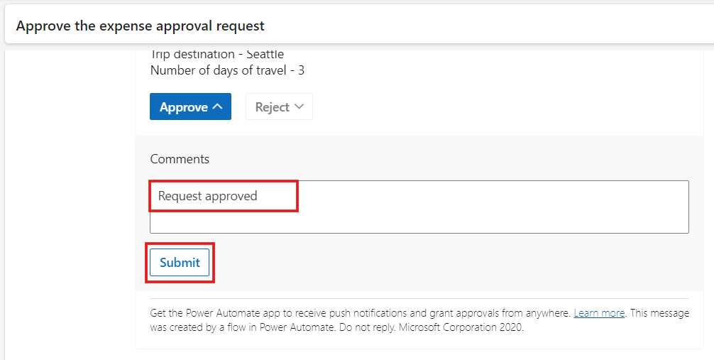

1. As soon as you click the **Submit** button, the requestor will get email notification.
2. To check the email notification received by the requestor, go to an InPrivate or Incognito window. On the new tab enter the URL <https://outlook.office365.com/> to browse **Microsoft Outlook**.
3. Sign in with the **Requestor credentials**. For this scenario, sign in with the credentials that are used for Mark Brown.
4. Once logged in, you can view the email notification that your **Expense approval request is approved**.

### Task 3: View different stages of Expense approval request flow

1. Navigate to the **Expense Report App**. Close it.

1. Select the matrix on the upper ribbon of Power Apps.

1. Select **Power Automate**.

1. You will be navigated to **Power Automate** Tab. Make sure that you are in the **Dev One** environment.

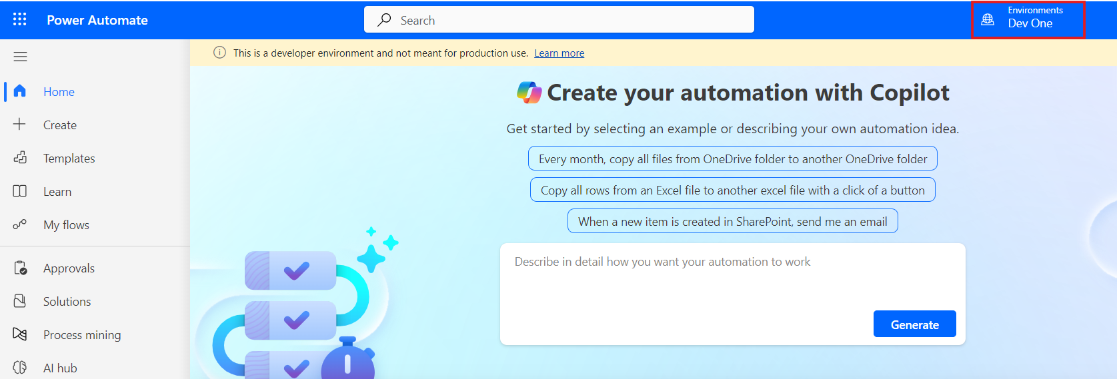

1. Select **My flows** and then select **Expense approval request flow**.

1. On the **Expense approval request flow** page, view the runs.
2. Select the status of the Expense approval request by Mark Brown. The status is ‘**Succeeded**’.

1. Open that run and see how the app automatically moves through the different approval stages.

### Task 4: Reject the Expense approval request

1. Submit the Expense approval request using the steps in **Task 7: Test the app**.
2. Once you submit the **Expense approval request**, you will receive an email on your **Tenant Admin Outlook account**.
3. Check the details and select **Reject**.

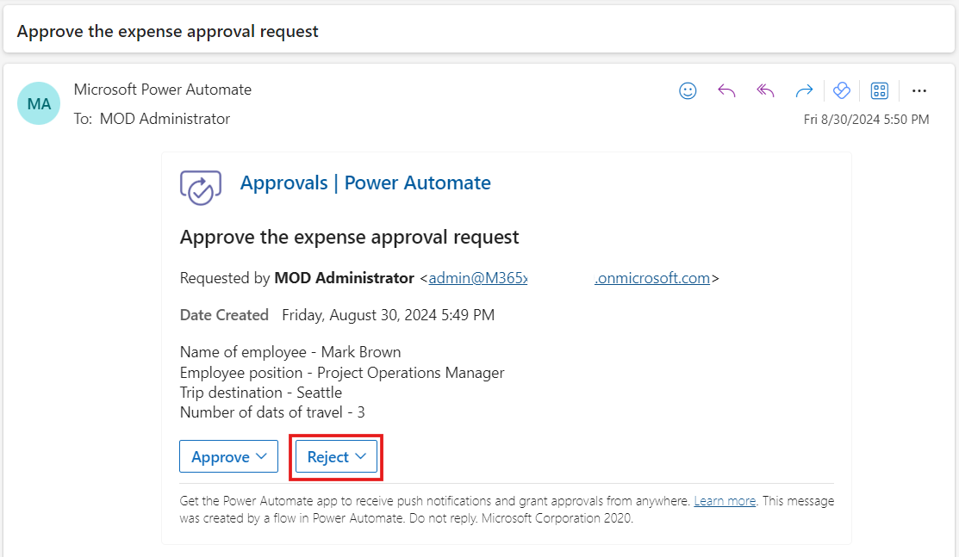

1. Write in the comments box – ‘**Please check the maximum expenses limit that can be approved for this employee position.**’ Select **Submit**.

1. To check the email notification received by the requestor, go to an InPrivate or Incognito window. On the new tab enter the URL <https://outlook.office365.com/> to browse **Microsoft Outlook**.
2. Sign in with the **Requestor credentials**. For this scenario, sign in with the credentials that are used for Mark Brown.
3. Once logged in, you can view the email notification that your **Expense approval request is rejected**. View the comments.

### Conclusion

Upon the conclusion of this exercise, you will possess:

1. A thoroughly tested **Expense Report App** that has successfully addressed both potential outcomes: the approval and rejection of an Expense Approval request.
2. An analysis of the different stages involved in the Expense approval request process after submission.

This ensures that you have a comprehensively tested and validated **Expense Report App**, facilitating the efficient management of employee expense approvals.